Version 1.2

21/10/2015



Version 2.1

Jack Irving

Fangfang Huang

Nasser Al’Oqayli

Version 1.2 20/10/2015

**Jak Irving;**

**Fangfang Huang**

**Nasser Aloqayli**

Contents

Introduction 2

Delivery Cycle Overview 2

Overall Delivery Cycle Plan 2

FDD: 2

Delivery Cycle Time Table 3

Function description 3

Customer Update Profile – Function 5.1.1 3

Customer Change Password – Function 5.1.3 3

Admin Update Profile – Function 7.2 3

Admin Change Password – Function 7.7 4

Manage Customers – Function 7.3 4

Add new customer- Function - 7.3.1 4

Delete customer. – Function 7.3.4 4

Manage Items – Function 7.5 4

Add New Product – Function 7.6.1 4

Acceptance Forms 4

Website Url 4

Forms: 5

Customer Update Profile 5

Customer Change Password 5

Admin Update Profile 6

Admin Change Password 7

Add New Customer 7

Delete Customer 8

Add New Product – Function 8

Appendix 8

# Introduction

It is the aim of this report to provide the client with an understanding of where the current system is in terms of development. This report will cover the delivery cycles to come and how the current delivery cycle 2 fits into the overall build of the system. Secondly the current version of the system will be explained with the completed functions and their descriptors. Lastly the report will allow for the client to provide some feedback and or acceptance with regards to the completed functions.

# Delivery Cycle Overview

## Overall Delivery Cycle Plan

### FDD:

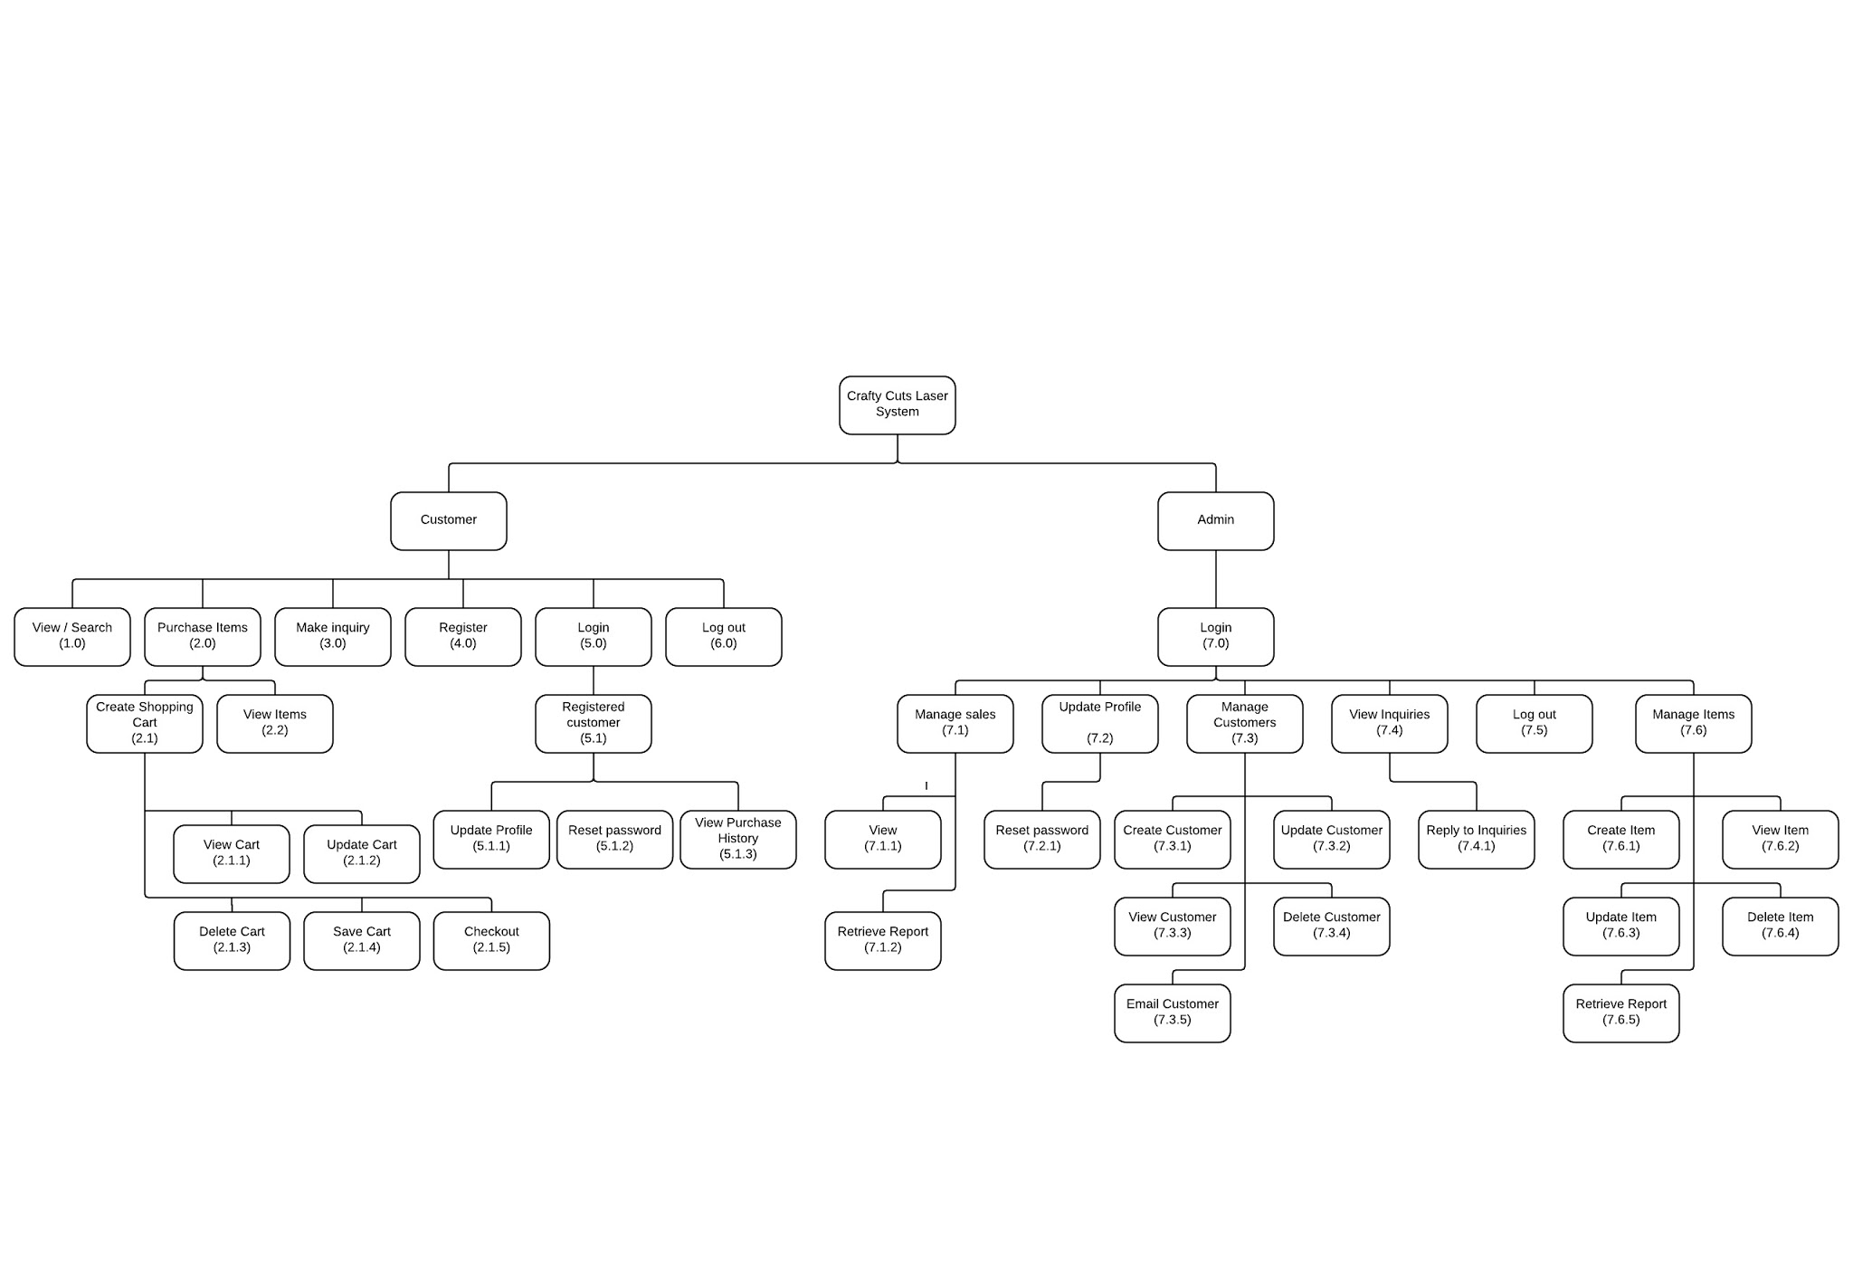

### Delivery Cycle Time Table

|  |  |  |
| --- | --- | --- |
| Delivery cycle | Tasks | Delivery Date |
| Delivery Cycle 2 | * (5.1.1) Customer update profile. * (5.1.2) Customer Change Password * (7.2) Admin update profile. * (7.3) Manage customers.   + (7.3.1) Add new customer.   + (7.3.4) Delete customer. * (7.5) Manage items.   + (7.6.1) Create item. * (7.7) Admin Change Password. | **21-Oct-2015** |
| Delivery Cycle 3 | * (7.1) Manage sales.   + (7.1.1) View sale. * (4.0) Customer makes inquiry. * (7.4) Admin view inquiries.   + (7.4.1) Reply to inquiries. * (5.1.3) Customer view purchase history. * (7.3.2) Update Customer * (7.6.2) View item * (7.6.4) Delete item * (7.6.3) Update Item | **30-Nov-2015** |
| Delivery Cycle 4 | * (7.1.2) Retrieve sales report. * (7.6.5) Retrieve items report. | **10-Dec-2015** |

# Function description

## Customer Update Profile – Function 5.1.1

Once a customer has logged in successfully they are able to update their profile by first clicking on the My Account tab in the top right of the screen and then they can change their profile information by clicking on “Edit my profile” from the menu provided.

Once there, a customer can edit their first name, last name, shipping address and phone number.

## Customer Change Password – Function 5.1.3

Customer is required to be logged in. Then they go to their profile by clicking on “My Account”. From here they are able to click on “Change My Password” and then input a new password as required. They will then confirm their password on more time. If the passwords do not match an error message will be displayed. Once successfully changing the password, Customers will be logged out and prompted to log in again. Current password is not required as additional authentication.

## Admin Update Profile – Function 7.2

Admin can update their profiles the same way as Customers. Once the admin has logged in, they click on “My Account” and then "Edit my profile” from the menu provided. Once there an admin can change their details exactly like a customer.

## Admin Change Password – Function 7.7

Once logged in the Admin can go to My Account by clicking on the tab in the top right hand side of the screen and then click on Change My Password in the menu. From there the Admin will be required to enter a new password and then confirm it. Current password is not required as additional authentication. Once successful the Admin will be logged out and prompted to log back in.

## Manage Customers – Function 7.3

### Add new customer- Function - 7.3.1

While logged in the Admin clicks on My Account and goes to Add New Customer. This tab is selected from the menu available to the Admin. Once the Admin has filled out all the necessary details they are able to create a new user. This form is exactly like the registration form. All fields are expected to be filled out correctly and passwords must be 8 characters or more.

### Delete customer. – Function 7.3.4

While logged in the Admin clicks on My Account and goes to View All Customers. Once there the admin may choose to delete a customer by clicking on delete. No confirmation will be required.

## Manage Items – Function 7.5

### Add New Product – Function 7.6.1

Once the admin is logged in, to add a new product they go to their account by clicking on “My Account” from here they are presented with a menu. Select “Add new product” from here they are taken to the products mage.

Input Product Name and description before submitting. From here the product has been saved. The Admin is presented with a confirmation message “The product has been saved”. From here the admin can add further details to the product by first selecting the product name of the product and then inputting further details. After successfully inputting the product details the Admin will be presented with a message.

Finally the Admin can upload an image for the product.

# Acceptance Forms

## Website Url

Url: http://ie.infotech.monash.edu/team304/Build2/review/cakephp/

## Forms:

### Customer Update Profile

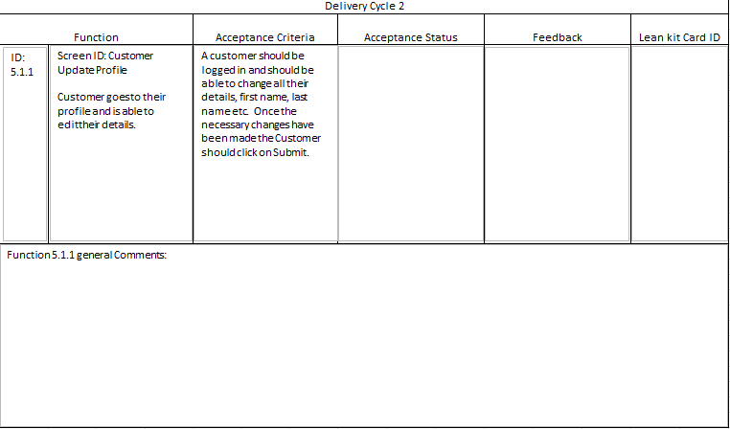

### Customer Change Password

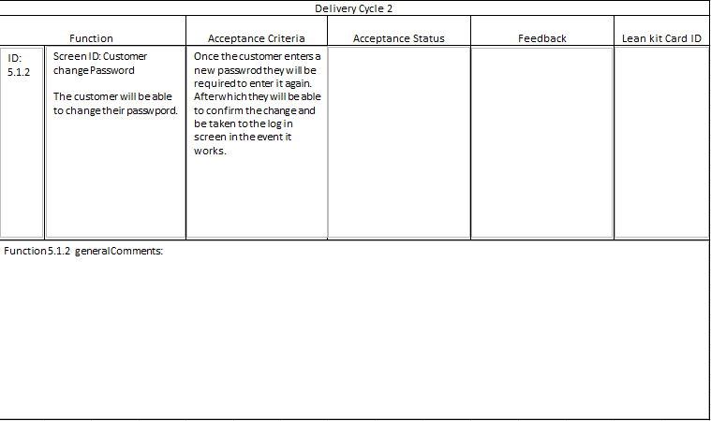

### Admin Update Profile

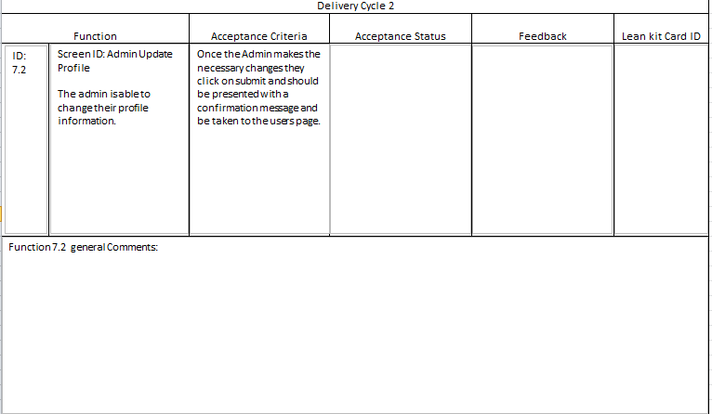

### Admin Change Password

### Add New Customer

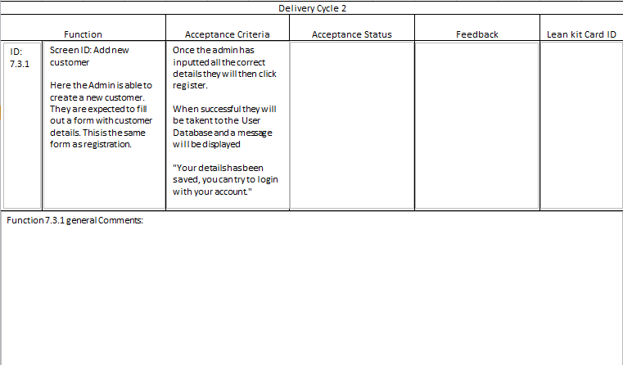

### Delete Customer

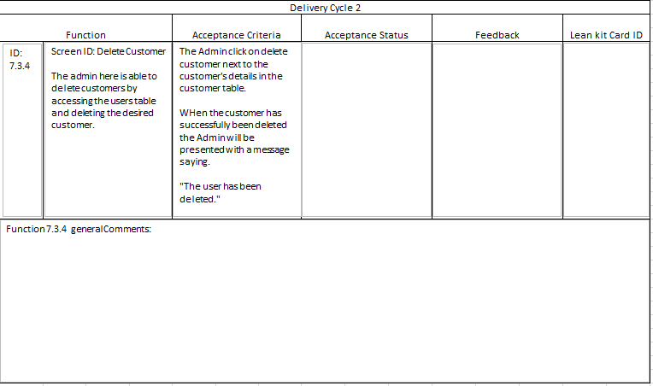

### Add New Product – Function

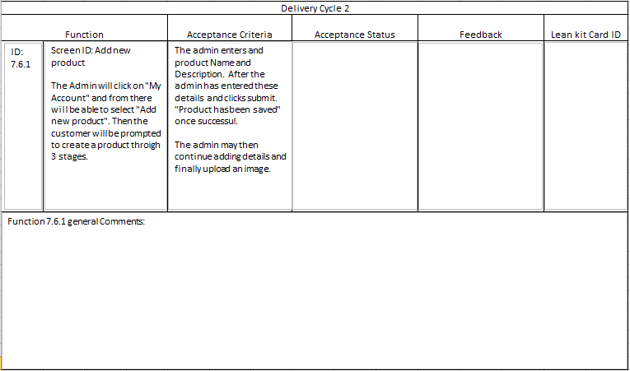

Client Sign off Statement

**I ______________________ of ___________________ agree that this system overview report currently covers my requirements with the understanding that any changes discussed will be made. Also, I understand that I may make changes throughout the project.**

**______________________**

**Client Signature & Date**

**______________________**

**Team Representative & Date**